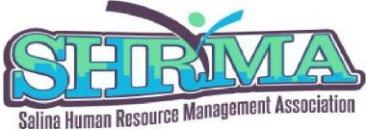 Date of Application: ________
Certification Test Support: $500 Tuition LOAN Assistance OR $350 Scholarship Award
Name of Applicant: __________________________________________________________________
Phone number: _____________________________________________________________________
Email address: ______________________________________________________________________
Place of Employment: ________________________________________________________________
Position/Title: ______________________________________________________________________
Time at current job: _________________________________________________________________
Description of responsibilities: _________________________________________________________
__________________________________________________________________________________
Your HR related goals for the next 12 months: ____________________________________________
__________________________________________________________________________________
Have you received any other funds/loan forgiveness towards Certification Y $___ NO NA
Tuition Assistance or Scholarship requested for what course or exam? ________________________
Date and location of class _____________________________________________________________
Attach documentation of existing loan, exam receipt, study material, on-line Certification Prep class.
Would you consider increasing your Chapter level of involvement if you were to receive this assistance?
In what areas would you have interest in:
Circle all that apply: Chapter Board role Speaker recruitment Diversity Day Host Membership Drive Programs

Sign ___________________________________________ Date ____________________
Please return this Loan Assistance/Scholarship Application to Kim Hoelting, 103 N. 9th, Salina, KS 67401.
Applications accepted through 10-22-21.

