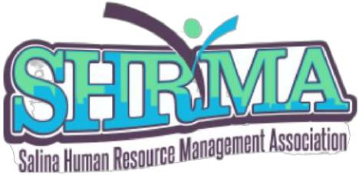
Diversity of Excellence Award Nomination Form

Nominee’s name: __________________________________________________________________________

E-mail, phone number: ______________________________________________________________________

Place of work: _____________________________________________________________________________

Your name & contact information: ____________________________________________________________

Check one:
- Employee Leadership Award
- Management Leadership Award

Reason for Nomination (be specific):

This nomination form is to submit the name of a candidate for the Salina Human Resource Management Association (SHRMA) Diversity of Excellence Award, to be presented at the SHRMA Virtual Diversity Summit on Thursday, October 21, 2021.
This award is presented to an individual who can exhibit excellence in living and promoting behaviors that demonstrate diversity, inclusion and cultural competence. This awardee represents openness in thinking and they embrace differences that promote equal opportunity in race, religion, culture, sexual identification and expression, thought processes, etc. This person brings awareness to diversity and inclusion in the workplace and community.
Submit this form to bcox@srhc.com before OCTOBER 4TH, 2021.

