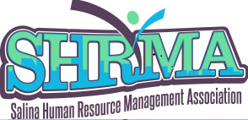Salina Human Resource Management Association
As a SHRM Affiliated Chapter, SHRMA promotes dual membership!
ALL Dual Members will be entered into a drawing for a $100 gift certificate!
SHRMA Winter Dual Membership Blitz
Deadline to achieve dual membership is November 30, 2021
$100 drawing to be held at our December Appreciation Event

If you are a national SHRM member, SHRMA’s membership fees are reduced from $80 to $50 annually (proration occurs after January yearly).

To become a member of SHRM and be entered into our drawing, go to https://www.shrm.org/ and click on Membership

SHRMA member benefits:
- Hear From the Experts at Monthly Workshops (lunch and giveaways)
- Earn PDCs for HRCI and SHRM Certification
- Network with Fellow HR Professionals
- Member Appreciation Events
- Opportunities to grow your leadership potential as a Board member
- Certification and loan forgiveness scholarship opportunities
- All in one spot - Link to SHRM from SHRMA’s website

SHRM member benefits:
- SHRM provides tools, samples, resources, news and experts, to help you excel in your role. And save time using SHRM’s free Ask an Advisor Service)

- Whether you are new to HR or looking to advance your career, SHRM can help with your professional development (SHRM-CP/SHRM-SCP Certifications, Professional Development Tools, Competency-Based Education Programs)

- With over 300,000 members worldwide, SHRM offers opportunities to build your network (Chapters & State Councils, SHRM Connect, SHRM’s Executive Network)

