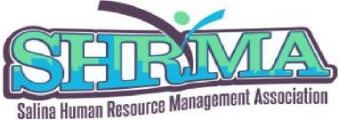

2021 SHRMA Certification Blitz
Scholarship and Tuition Awards Available
Are you a SHRMA current or new member who are considering sitting for
Certification Exams

Benefits of Certification
An investment in your career!
Supports your learning and development for the future.
Even stronger network affiliations with fellow HR Professionals.
Enhances sharing of best practices and new insights for leading the function of HR.

Certification Testing Award Opportunities through 10-22-21

Certification Scholarship Assistance $350.00
Loan Forgiveness Assistance $500.00

As a SHRM Affiliated Chapter, we promote and support
the certification journey and the benefits it will deliver.

By October 22, 2021, call/email Kim Hoelting, Certification Chair for more information about the Certification exam process at 785-342-0819 or by emailing kim.hoelting@salinadiocese.org to learn more about these
two assistance opportunities or to request the Application.

